Meeting Minutes 23.01.2025
Bias Voltage Level
- Set for 1.7V
  - Too see if the signal is being well defined get the difference between the 2 outputs (drag the cursor between the two and compare it with the input signal and see how well they match
  - Changed the input current pulse range from the nominal 50 to 100 because that is the full utilized range -> this gives a more accurate depiction of the range of power consumption by the dual op amp
    - Measure the current at the 5Vcc input and now it is a more accurate representation with the quiescent current as well -around 2A
- 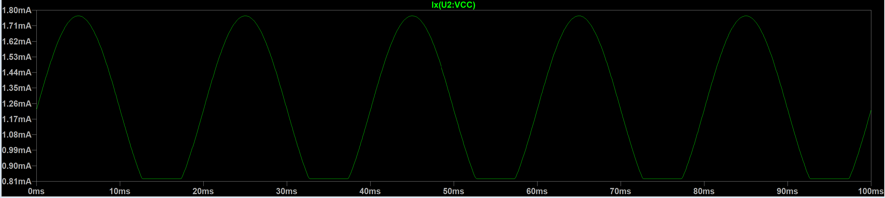
- The 2.5VOCM pulls barely any current
- 1.7V bias pulls around 1mA
  - HOWEVER THE FEEDBACK RESISTORS NEED TO BE CHANGED
    - First: we need Gain to get it from the 3.3V level to 5V level
    - Second: we can change the resistor values in the – input with the 1.7V if we have higher resistors in combination to form the same gain, we can depending on this make the current flow through R10 and not through the differential op amp itself – depending on the current output of the voltage reference
  - Resistors of 10k and 6k68 -> investigate
  - This will change the current pull the whole op amp circuitry!!!

Power Schematic Design
- 1.7V Bias Voltage
  - Use a voltage reference REF35170
  - Look at the current output we need and change the feedback resistors on the fully differential op amp to vary the current
- 2.5VCOM
  - Use same voltage reference as the 1.7V Bias Voltage
- 3.3V Level
  - Things to keep in mind when choosing an LDO (picture taken on phone)
  - https://www.ti.com/product/TPS7A20 go with SOT23

Estimating Current Pull of all the components
Design types: Push Pull Output or Open Drain Output
Transmitter:
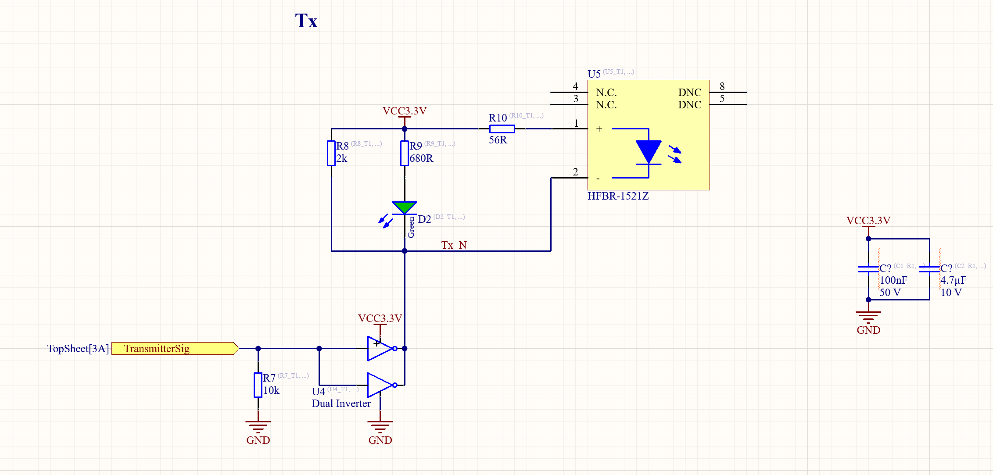
The transmitter itself is a red LED – diode has a threshold voltage – depending on what value I choose the brightness of the LED changes – choose voltage and calculate current pull with this
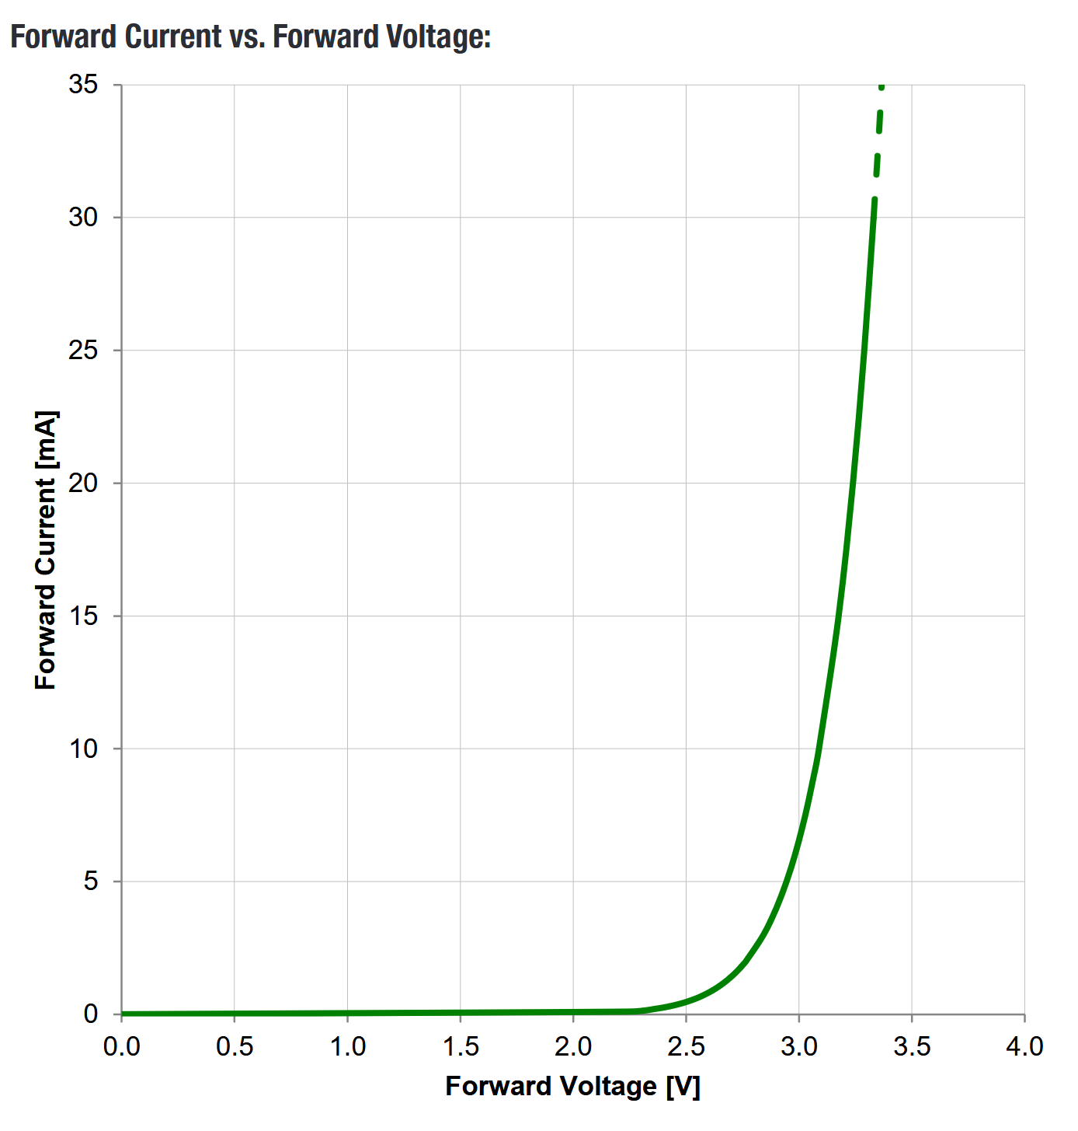
The green LED diode as well – choose voltage drop on the diode and calculate current pull
The 2k resistor R8 is there because of legacy – keep and calculate current pull

Dual Inverter
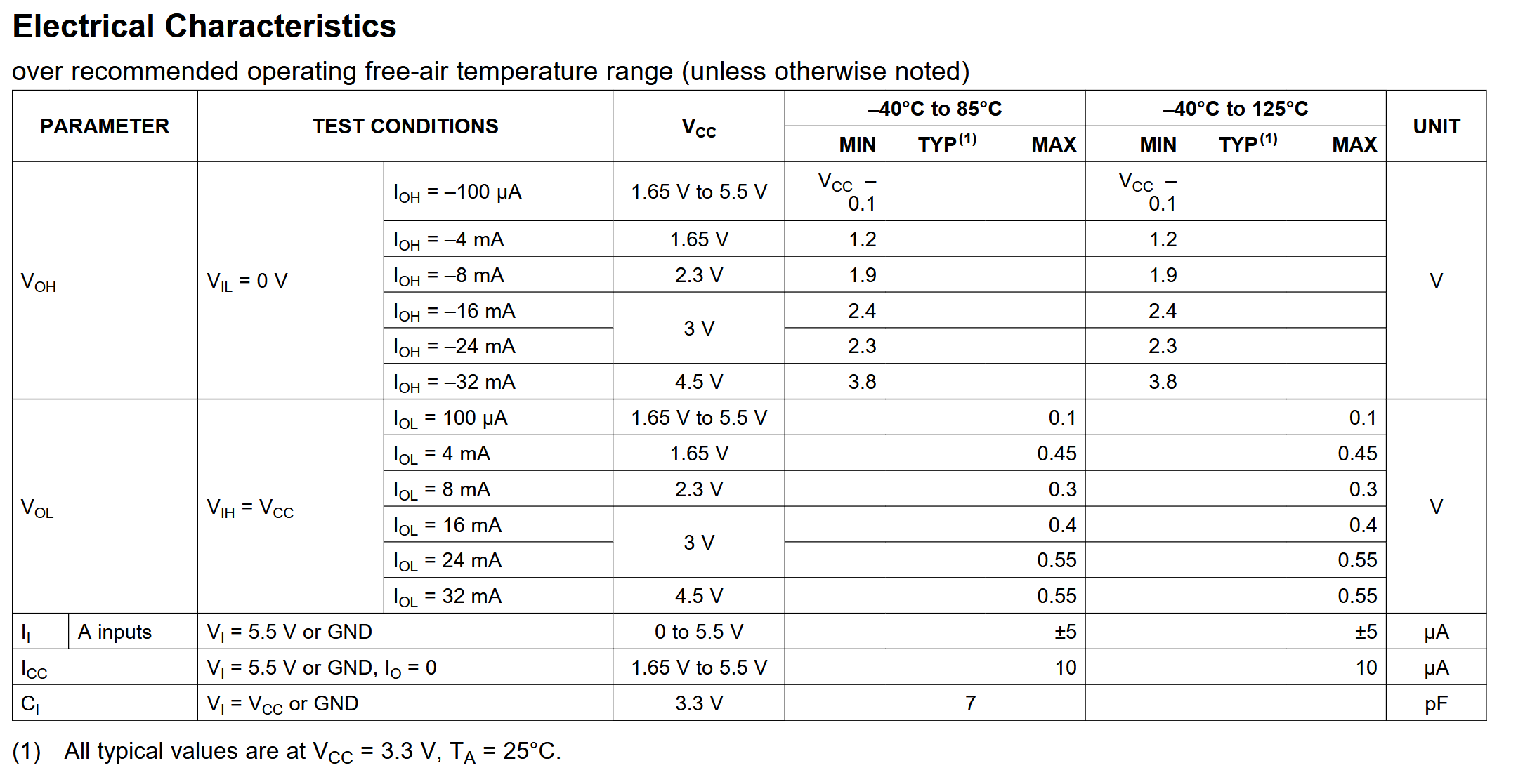
Depending on V_IL or V_IH voltage input low or high – there is different output currents

Reciever:
Look into data sheet again it is really confusing with the input low/high and the high and low logic
- I think no light means input high light means input low – can look at the dbaud levels if it is lower than the light is off
- And then there is the inverter that inverts the signal to tell us what the real meaning is
- Look into data sheet

After Calculating Everything do an LTspice simulation to verify the calculations.
Estimated values in Excel Sheet

Decoupling capacitors
- Generally decoupling capacitors needed for all the power supplies
  - 5V and GND 100nF decoupling capacitors
  - Also for the 1.7V bias 100nF
  - Also for overcurrent dectection – look at datasheet

Ferrite Bead
- Have 2x2 pin header for the external 5V input
- 3x ferrite beads so if we don’t want one power level we can unsolder
  - LED indicator for 3.3V rail so we know when it is turned on

For the fully differential op amp in the back there is 10k resistor because the ADC card is high impedance

Make sure Test points are SMD
For Testing circuit:
- Get the edge card connector from the wolfspeed model
- And then put it out on a pcb board and break the signal so that it can be reached using test pins

